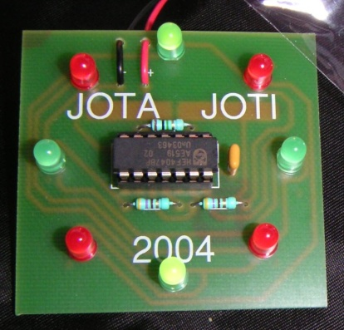
We would like to introduce you to this fun little electronics project. We’ll build this circuit together step by step, it can not go wrong. As the name suggests the lights spin around like the blades of a Dutch windmill. Have fun building!

REQUIRED PARTS:
R1 = 1 M ohm resistor, brown, black, green
R2-3 = 470 Ohm resistor, yellow, purple, brown
C1 = 100nF capacitor (104)
D1-8 = LED red and green, 5mm
IC1 = 4047
1 x 14-pin IC socket
1 x 9V battery clip (Red = + Black = -)
1 x 9V battery (not included)
1 x PCB
1 x safety pin
1 x piece of solder (not included)

BUILDING TECHNICAL DESCRIPTION:

In the building instructions we refer to the picture above and white print on the board Place the PCB with the non-copper side towards you so you can see the white print. The parts must be mounted on this side of the PCB. After placing a component to the PCB, reverse the board for soldering.

The resistor R1 is mounted first. It has different colour rings as the other two resistors! Bend the legs, and put the resistor at the designated place and solder them down.

The resistors R2 and R3 are next. These have the same colour rings and are placed next to each other on the board.

Search, insert and solder the capacitor C1 now.

The 8 red and green lights (LED’s) are next to be soldered. If you look closely to the LED’s you will see that they have one long leg and one short leg. The short leg is called the cathode. The word starts with "k" in Dutch so look at the board where the "k" is shown. Solder the LED’s on the PCB surface. The red and green lights take turns, first one green, one red, one green, etc.
Check that the position of the LED is correct before you solder it.

Insert the IC socket on the PCB. Make sure that all fourteen pins are well placed and are stabbing through the holes. Bend the pins on the 4 corners, so the socket cannot fall out. Solder all the 14 pins.

Then we have the safety pin. This pin is not only useful to attach the PCB to your shirt, but also acts as a switch for the battery. Cut the stem of the safety pin through the middle with a sturdy wire cutter . See detailed drawing. Turn the board over and solder the two pin portions on the buyer side of the PCB. Note the correct distance so that the pin will still close.

Finally solder the 9 volt battery clip. Besides the two terminals are two extra holes applied as a wire strain relief . DO NOT swap the red and black wires !

Remove the IC from the special packaging and place in the IC socket. Note the notch on the IC. That should point to the capacitor C1. Gently press the IC into the socket. Avoid touching the legs because they are very sensitive to static charge.

Connect a 9V battery.

Enjoy the windmill, be noticed in the dark!

